**Introduction**

* 3 minutes

**Scenario**

Azure Administrators use tools to interact with the cloud environment and complete such tasks as:

* Deploying dozens or hundreds of resources at a time.
* Configuring individual services using scripts.
* Viewing rich reports across usage, health, costs, and more.

You must select and use a tooling option. Your choices can include the Azure portal, Azure PowerShell, Azure CLI, or Azure Cloud Shell.

**Skills measured**

These administrative tools aren't directly tested on [Exam AZ-104: Microsoft Azure Administrator](https://learn.microsoft.com/en-us/certifications/exams/az-104). However, may be used during performance-based testing.

**Learning objectives**

In this module, you'll learn how to:

* Manage resources with the Azure portal.
* Manage resources with Azure Cloud Shell.
* Manage resources with Azure PowerShell.
* Manage resources with Azure CLI.

**Prerequisites**

None

**Next unit: Use the Azure portal**

**Use the Azure portal**

Completed100 XP

* 3 minutes

The **Azure portal** lets you build, manage, and monitor everything from simple web apps to complex cloud applications in a single, unified console.

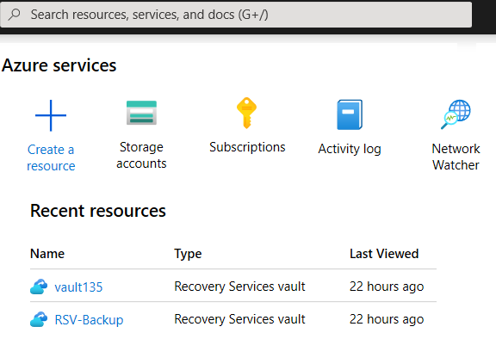

* Search resources, services, and docs.
* Manage resources.
* Create customized dashboards and favorites.
* Access the Cloud Shell.
* Receive notifications.
* Links to the Azure documentation.

**Note**

You can access the portal at [**https://portal.azure.com**](https://portal.azure.com/).

**Next unit: Use Azure Cloud Shell**

**Use Azure Cloud Shell**

Completed100 XP

* 3 minutes

Azure Cloud Shell is an interactive, browser-accessible shell for managing Azure resources. It provides the flexibility of choosing the shell experience that best suits the way you work. Linux users can opt for a Bash experience, while Windows users can opt for PowerShell.

Cloud Shell enables access to a browser-based command-line experience built with Azure management tasks in mind. You can use Cloud Shell to work untethered from a local machine in a way only the cloud can provide.

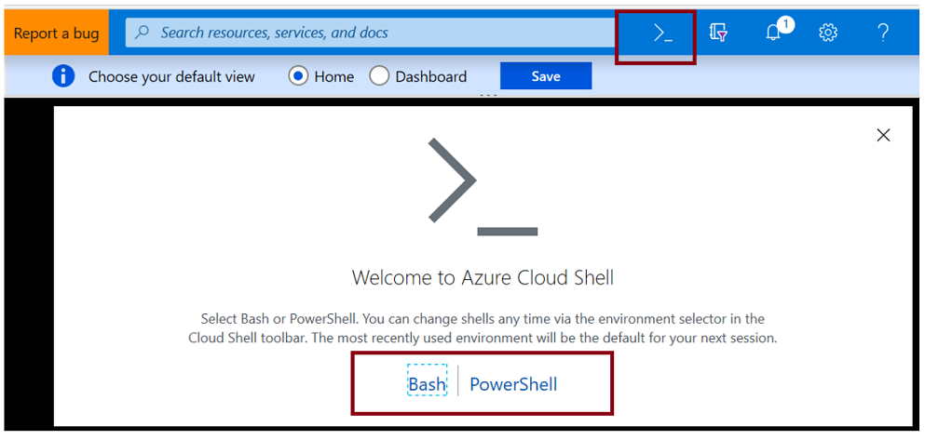

**Azure Cloud Shell features**

* Is temporary and requires a new or existing Azure Files share to be mounted.
* Offers an integrated graphical text editor based on the open-source Monaco Editor.
* Authenticates automatically for instant access to your resources.
* Runs on a temporary host provided on a per-session, per-user basis.
* Times out after 20 minutes without interactive activity.
* Requires a resource group, storage account, and Azure File share.
* Uses the same Azure file share for both Bash and PowerShell.
* Is assigned to one machine per user account.
* Persists $HOME using a 5-GB image held in your file share.
* Permissions are set as a regular Linux user in Bash.

**Next unit: Use Azure PowerShell**

**Use Azure PowerShell**

Completed100 XP

* 3 minutes

Azure PowerShell is a module that you add to Windows PowerShell or PowerShell Core to enable you to connect to your Azure subscription and manage resources. Azure PowerShell requires PowerShell to function. PowerShell provides services such as the shell window and command parsing. Azure PowerShell adds the Azure-specific commands.

For example, Azure PowerShell provides the **New-AzVm** command that creates a virtual machine inside your Azure subscription. To use it, you would launch the PowerShell application and then issue a command such as the following command:

PowerShellCopy

New-AzVm `

-ResourceGroupName "CrmTestingResourceGroup" `

-Name "CrmUnitTests" `

-Image "UbuntuLTS"

...

Azure PowerShell is also available two ways: inside a browser via the Azure Cloud Shell, or with a local installation on Linux, macOS, or the Windows operating system. In both cases, you have two modes from which to choose: you can use it in interactive mode in which you manually issue one command at a time, or in scripting mode where you execute a script that consists of multiple commands.

**What is the Az module?**

**Az** is the formal name for the Azure PowerShell module containing cmdlets to work with Azure features. It contains hundreds of cmdlets that let you control nearly every aspect of every Azure resource. You can work with the following features, and more:

* Resource groups
* Storage
* VMs
* Azure AD
* Containers
* Machine learning

This module is an open-source component [available on GitHub](https://github.com/Azure/azure-powershell).

**Note**

You might have seen or used Azure PowerShell commands that used an **-AzureRM** format. In December 2018 Microsoft released for general availability the AzureRM module replacement with the Az module. This new module has several features, notably a shortened cmdlet noun prefix of **-Az**, which replaces **AzureRM**. The **Az** module ships with backwards compatibility for the AzureRM module, so the **-AzureRM** cmdlet format will work.

Bookmark the [Azure PowerShell Reference](https://learn.microsoft.com/en-us/powershell/azure/?view=azps-6.5.0).

**Next unit: Interactive lab simulation (Azure PowerShell)**

**Interactive lab simulation (Azure PowerShell)**

Completed100 XP

* 15 minutes

**Lab scenario**

You're the Azure Administrator for your organization. You decide to automate some common administration tasks by using Azure PowerShell.

* Create resources groups.
* Create managed disks.
* Change the configuration of managed disks.

**Architecture diagram**

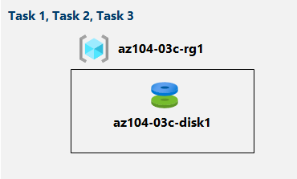

**Objectives**

* **Task 1**: Start a PowerShell session in the Azure Cloud Shell
* **Task 2**: Create a resource group and managed disk by using PowerShell.
  + Create a resource group.
  + Create a managed disk in the resource group.
* **Task 3**: Configure the managed disk by using Azure PowerShell.
  + Increase the size of the managed disk.
  + Change the disk performance SKU.

**Note**

Click on the thumbnail image to start the lab simulation. When you're done, be sure to return to this page so you can continue learning.

[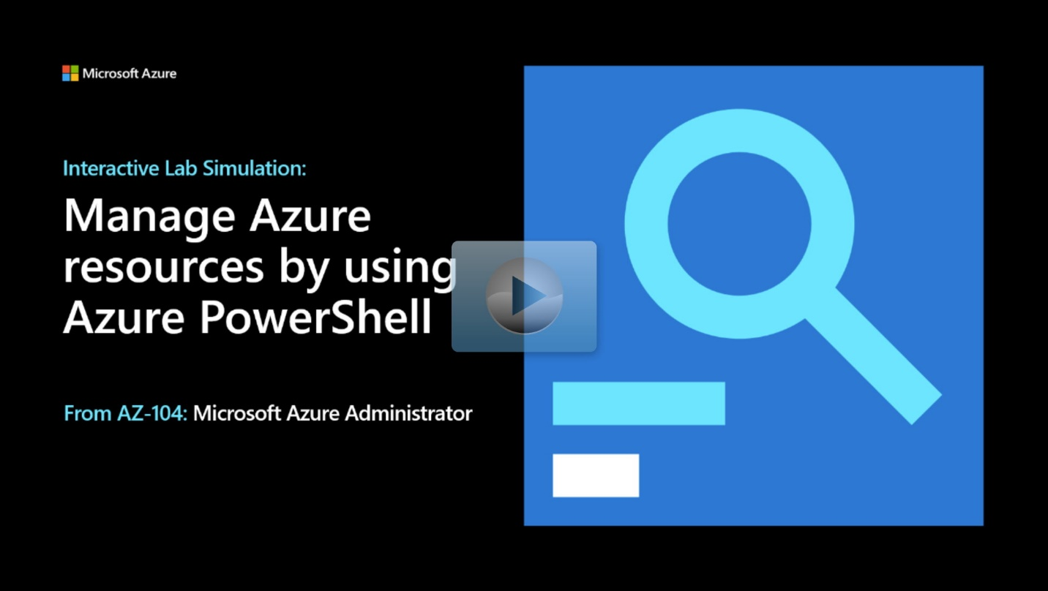](https://mslabs.cloudguides.com/guides/AZ-104%20Exam%20Guide%20-%20Microsoft%20Azure%20Administrator%20Exercise%206)

**Next unit: Use Azure CLI**

**Use Azure CLI**

Completed100 XP

* 3 minutes

Azure CLI is a command-line program to connect to Azure and execute administrative commands on Azure resources. It runs on Linux, macOS, and Windows, and allows administrators and developers to execute their commands through a terminal, command-line prompt, or script instead of a web browser. For example, to restart a VM, you would use a command such as the following:

Azure CLICopy

az vm restart -g MyResourceGroup -n MyVm

Azure CLI provides cross-platform command-line tools for managing Azure resources. You can install the CLI locally on computers running the Linux, macOS, or Windows operating systems. You can also use Azure CLI from a browser through Azure Cloud Shell.

In both cases, Azure CLI can be used interactively or through scripts:

* **Interactive**. First, for Windows operating systems, launch a shell such as cmd.exe, or for Linux or macOS, use Bash. Then issue the command at the shell prompt.
* **Scripted**. Assemble the Azure CLI commands into a shell script using the script syntax of your chosen shell. Then execute the script.

Azure CLI lets you control nearly every aspect of every Azure resource. You can work with resource groups, storage, VMs, Azure Active Directory (Azure AD), containers, machine learning, and so on.

Commands in the CLI are structured in *groups* and *subgroups*. Each group represents a service provided by Azure, and the subgroups divide commands for these services into logical groupings. For example, the storage group contains subgroups including **account**, **blob**, **share**, and **queue**.

So, how do you find the particular commands you need? One way is to use az find. For example, if you want to find commands that might help you manage a storage blob, you can use the find command:

Azure CLICopy

az find blob

If you already know the name of the command you want, the --help argument for that command will get you more detailed information on the command, and for a command group, a list of the available subcommands. For example, here's how you can get a list of the subgroups and commands for managing blob storage:

Azure CLICopy

az storage blob --help

**Note**

Bookmark the [**Azure CLI Reference**](https://learn.microsoft.com/en-us/cli/azure/).

**Next unit: Interactive lab simulation (Azure CLI)**

**Interactive lab simulation (Azure CLI)**

Completed100 XP

* 10 minutes

**Lab scenario**

You're the Azure Administrator for your organization. You decide to automate some common administration tasks by using Azure Command Line Interface (CLI).

* Create resources groups.
* Create managed disks.
* Change the configuration of managed disks.

**Architecture diagram**

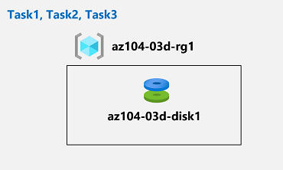

**Objectives**

* **Task 1**: Start a Bash session in the Azure Cloud Shell.
* **Task 2**: Create a resource group and a managed disk by using the Azure CLI.
  + Create a resource group.
  + Create a managed disk in the resource group.
* **Task 3**: Configure the managed disk by using the Azure CLI.
  + Increase the size of the managed disk.
  + Change the disk performance SKU.

**Note**

Click on the thumbnail image to start the lab simulation. When you're done, be sure to return to this page so you can continue learning.

[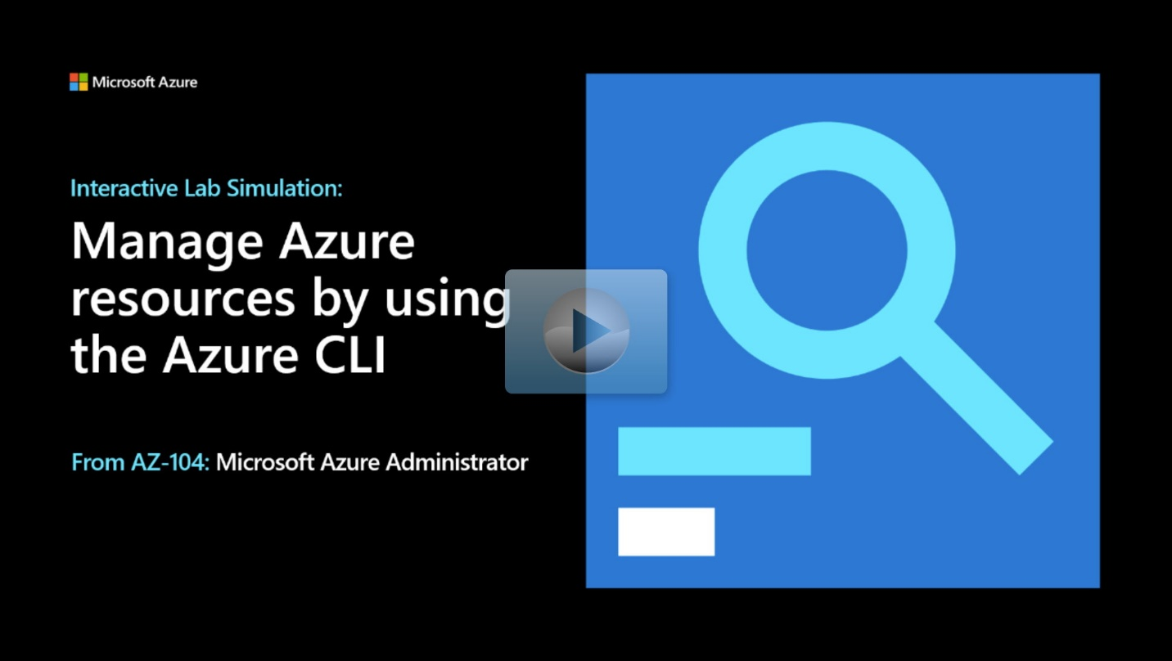](https://mslabs.cloudguides.com/guides/AZ-104%20Exam%20Guide%20-%20Microsoft%20Azure%20Administrator%20Exercise%207)

**Next unit: Knowledge check**

**Summary and resources**

* 3 minutes

Azure Administrators have many tools when it comes to managing resources. These tools include the Azure portal, Azure Cloud Shell, Azure PowerShell, and Azure CLI.

You should now be able to:

* Manage resources with the Azure portal.
* Manage resources with Azure Cloud Shell.
* Manage resources with Azure PowerShell.
* Manage resources with Azure CLI.

**Learn more**

You can learn more by reviewing the following. A *sandbox* indicates a hands-on exercise.

* [Azure portal documentation](https://learn.microsoft.com/en-us/azure/azure-portal/)
* [Azure Cloud Shell overview](https://learn.microsoft.com/en-us/azure/cloud-shell/overview)
* [Azure PowerShell documentation](https://learn.microsoft.com/en-us/powershell/azure)
* [Azure CLI Reference](https://learn.microsoft.com/en-us/cli/azure/?view=azure-cli-latest).
* [Manage services with the Azure portal (Sandbox)](https://learn.microsoft.com/en-us/training/modules/tour-azure-portal/)
* [Introduction to PowerShell (Sandbox)](https://learn.microsoft.com/en-us/training/modules/introduction-to-powershell/)
* [Control Azure services with the CLI (Sandbox)](https://learn.microsoft.com/en-us/training/modules/control-azure-services-with-cli/)
* [Control and organize Azure resources with Azure Resource Manager](https://learn.microsoft.com/en-us/training/modules/control-and-organize-with-azure-resource-manager/)